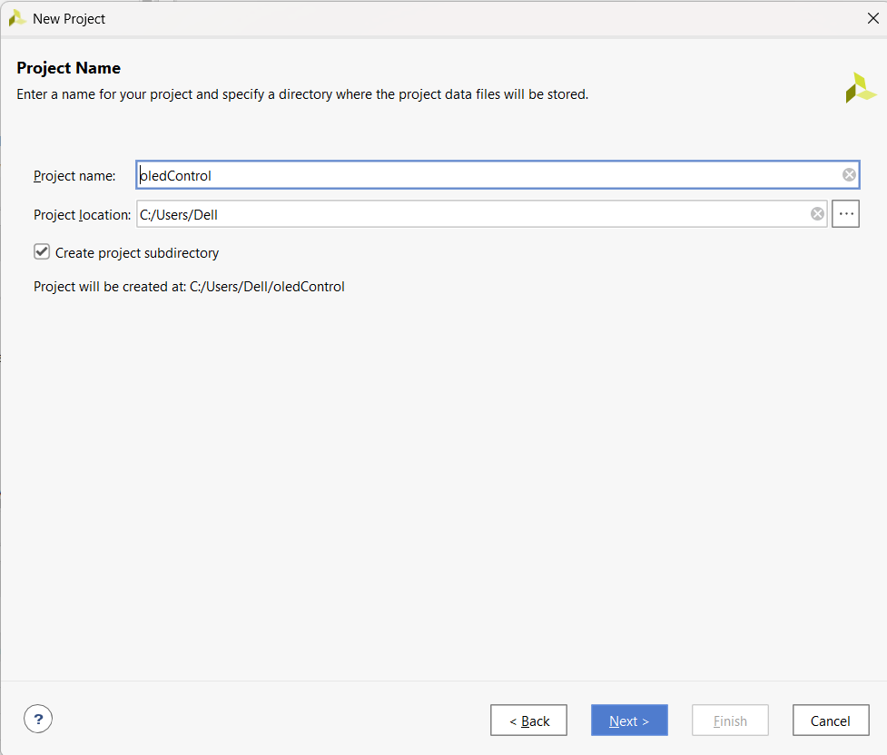
Make New Project
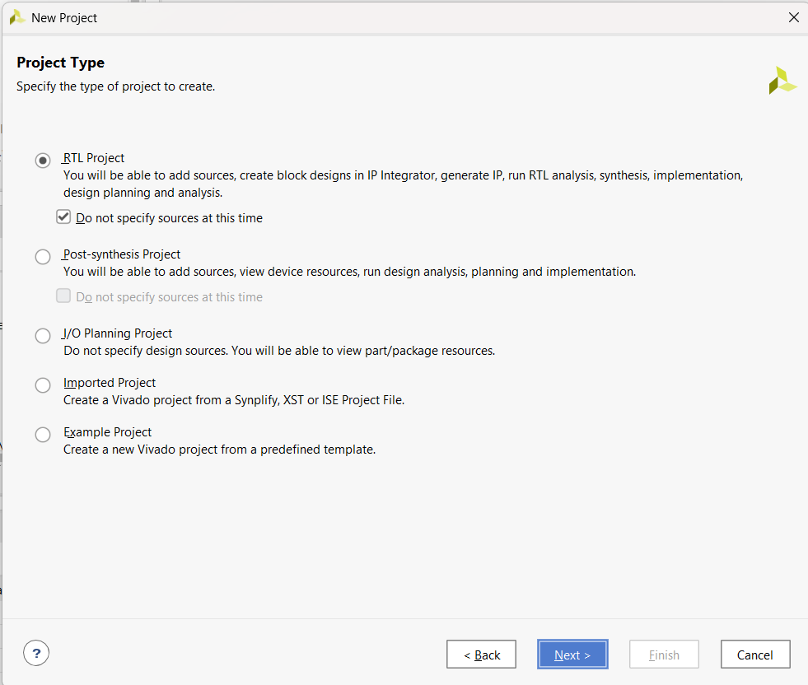
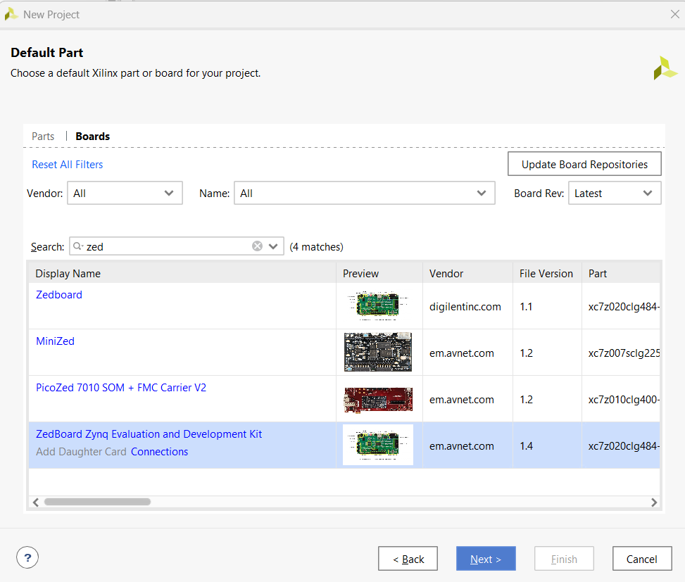
Select Board
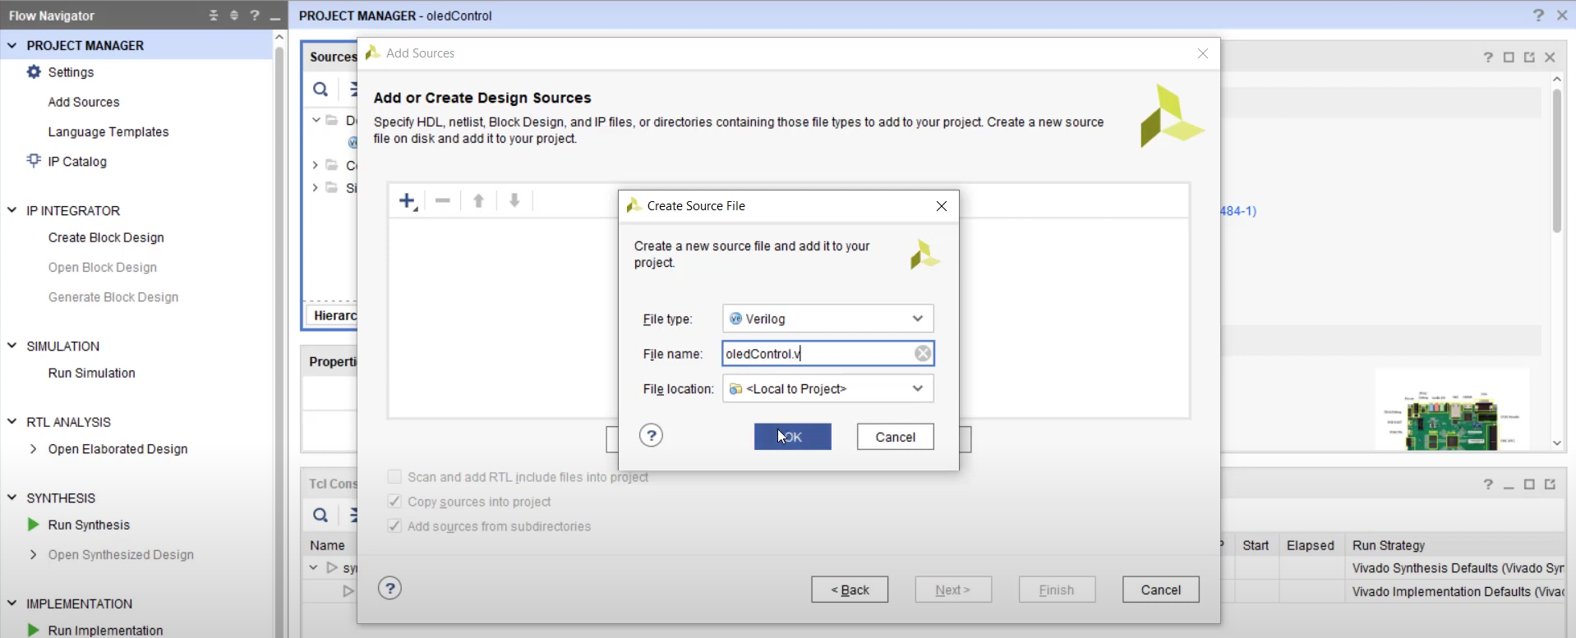
Click Add Sources -Next – Crete File - Name (oledControl.v) and ok
All Codes attached at the end of Document
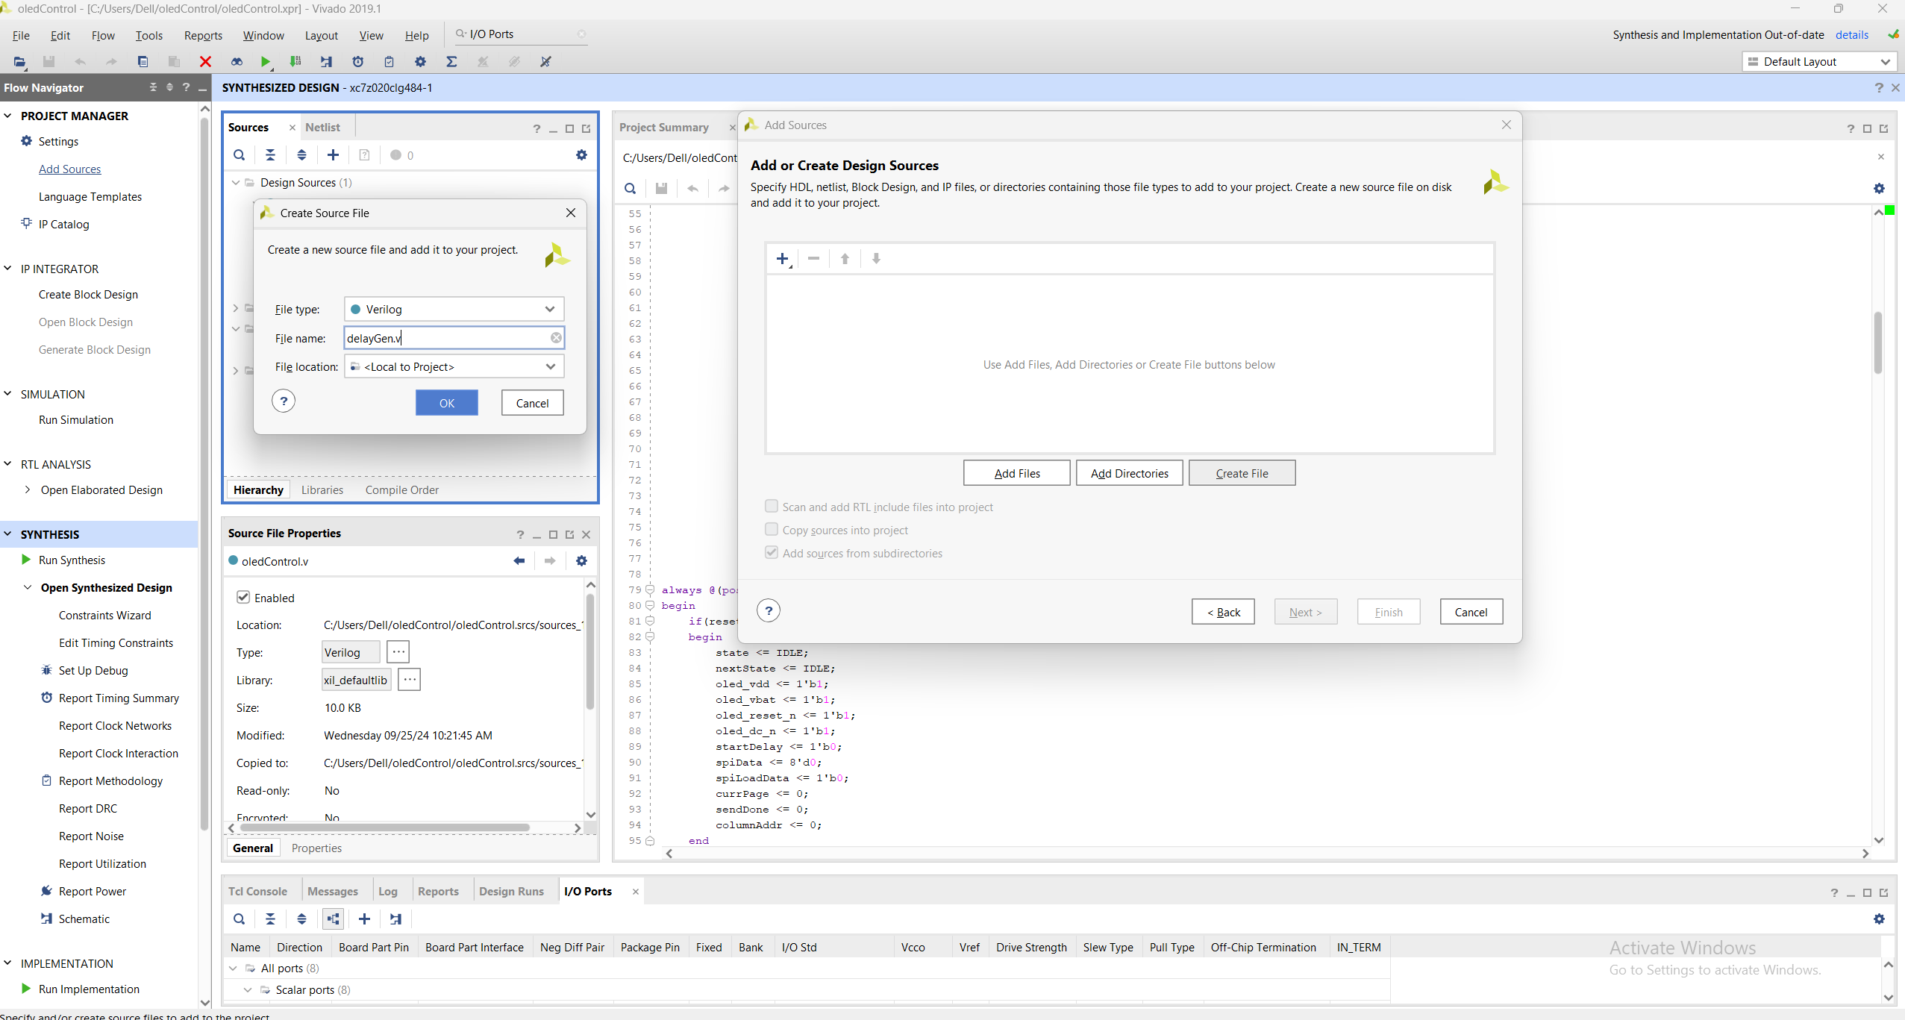
Click Add Sources -Next – Crete File - Name (delayGen.v) and ok
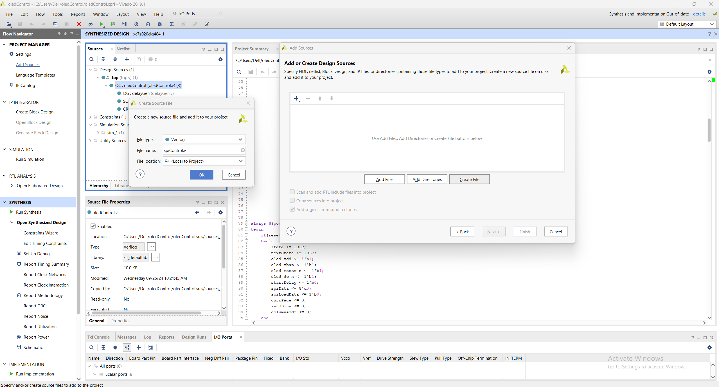
Click Add Sources -Next – Crete File - Name (spiControl.v) and ok
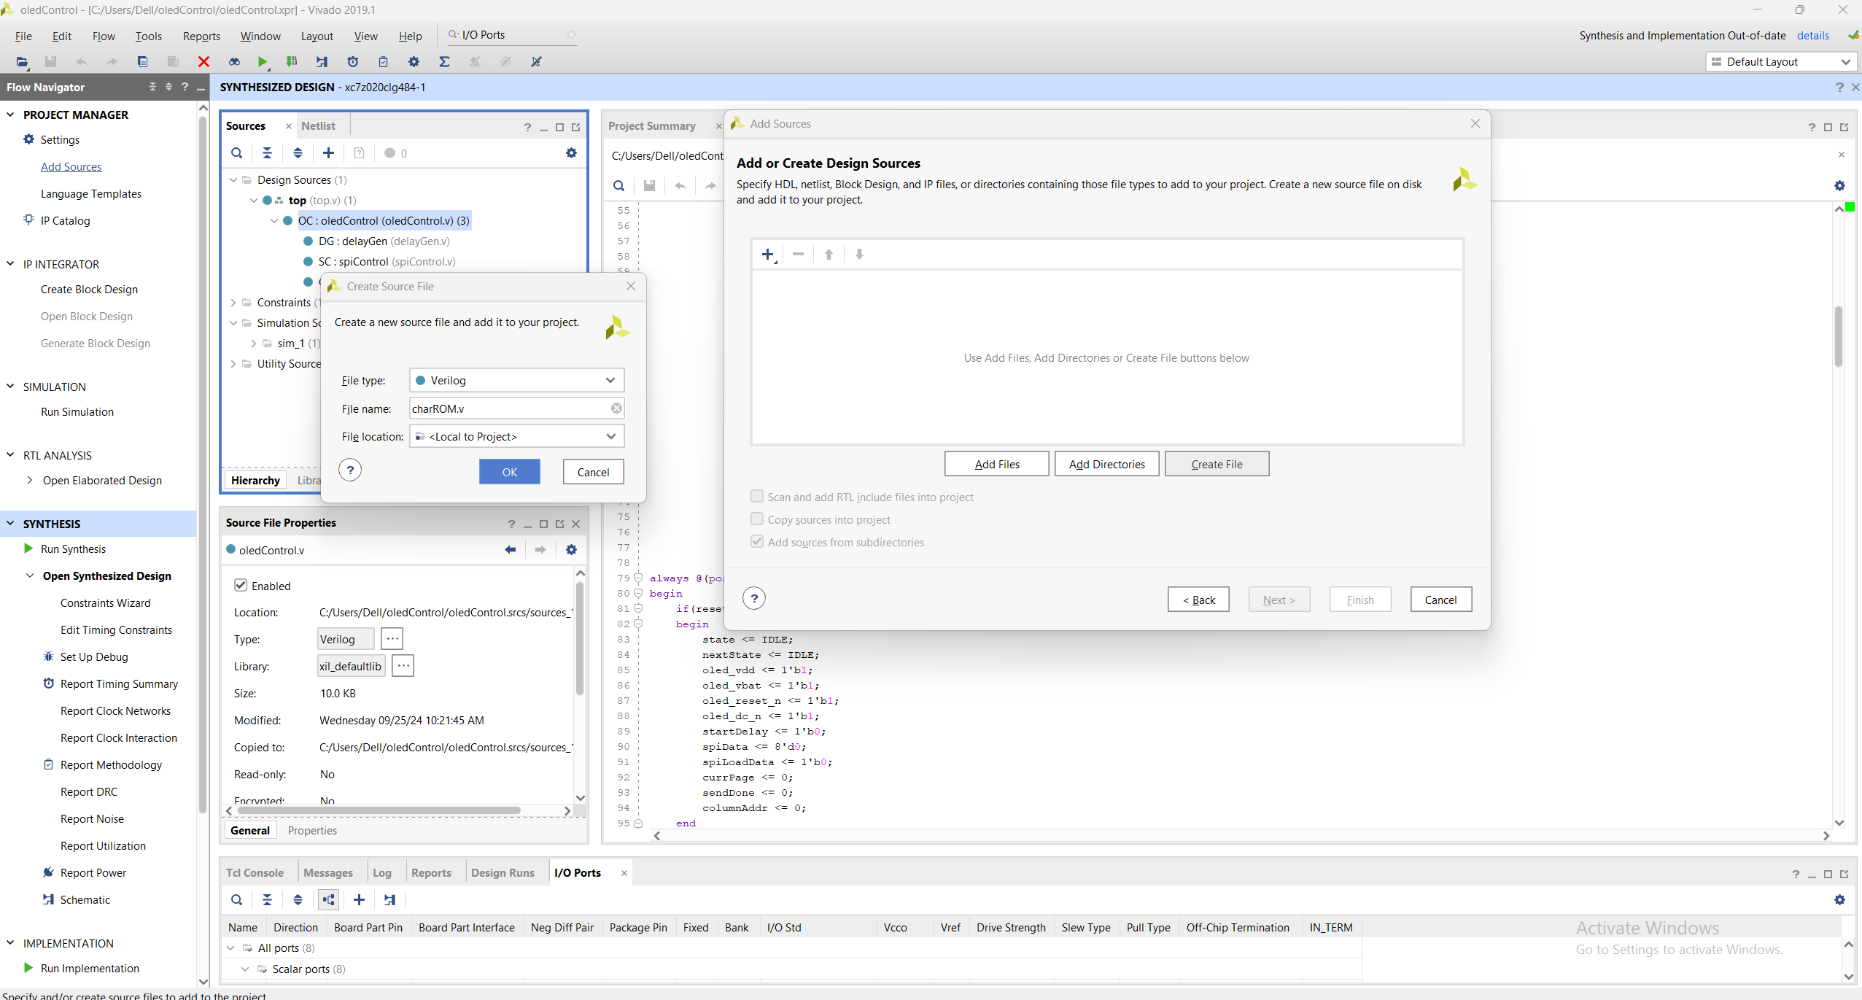
Click Add Sources -Next – Crete File - Name (charROM.v) and ok
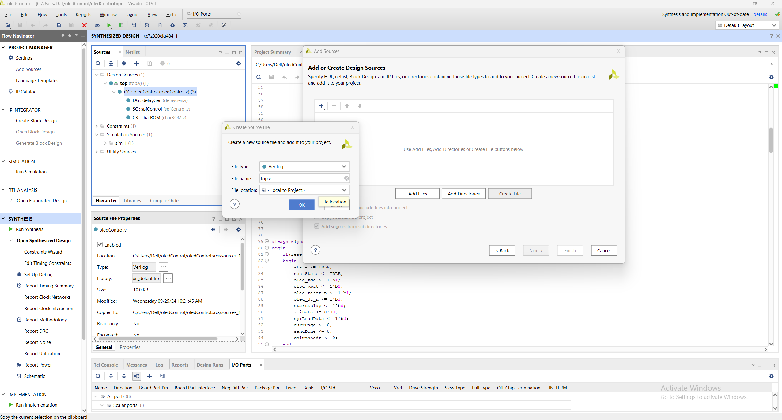
Click Add Sources -Next – Crete File - Name (top.v) and ok

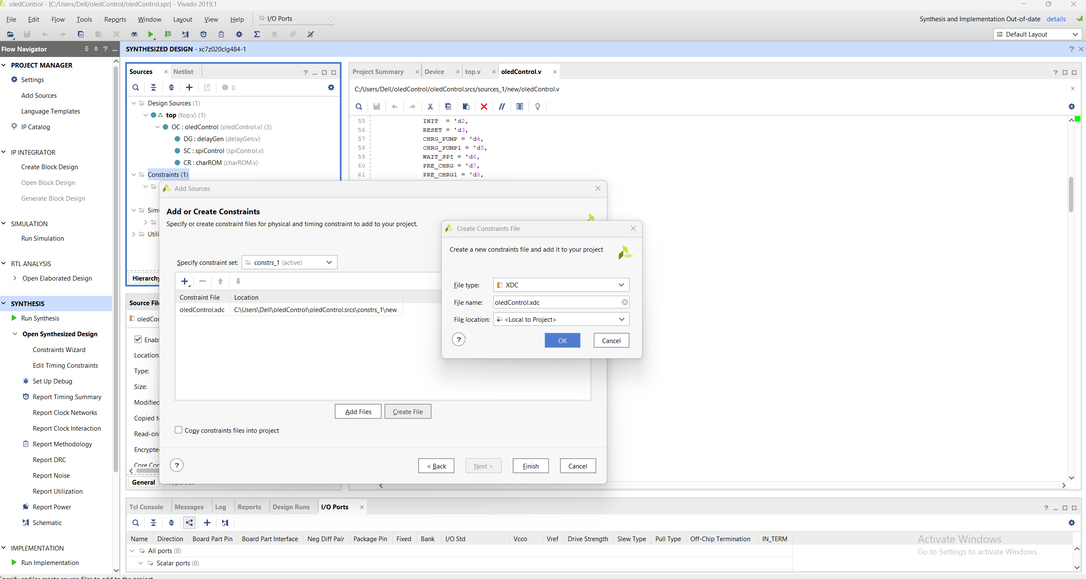
Click Constraint Add source create constraint File “oledControl.xdc”

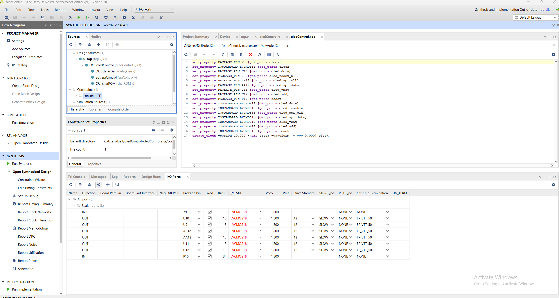
Set Package Pins
Now Run Synthesis – Run Implementation – Generate Bitstream
Now Open Hardware Manager – Open Target – Auto Connect – Program device.
TOP.V Code

`timescale 1ns / 1ps
//////////////////////////////////////////////////////////////////////////////////
// Company:
// Engineer:
//
// Create Date: 09/25/2024 11:21:49 AM
// Design Name:
// Module Name: top
// Project Name:
// Target Devices:
// Tool Versions:
// Description:
//
// Dependencies:
//
// Revision:
// Revision 0.01 - File Created
// Additional Comments:
//
//////////////////////////////////////////////////////////////////////////////////

module top(

input clock, //100MHz onboard clock
input reset,
//oled interface
output oled_spi_clk,
output oled_spi_data,
output oled_vdd,
output oled_vbat,
output oled_reset_n,
output oled_dc_n
);

localparam myString ="Farhan Siddiqui";
localparam StringLen = 15;

reg [1:0] state;
reg [7:0] sendData;
reg sendDataValid;
integer byteCounter;
wire sendDone;

localparam IDLE = 'd0,
SEND = 'd1,
DONE = 'd2;

always @(posedge clock)
begin
if(reset)
begin
state <= IDLE;
byteCounter <= StringLen;
sendDataValid <= 1'b0;
end
else
begin
case(state)
IDLE:begin
if(!sendDone)
begin
sendData <= myString[(byteCounter*8-1)-:8];
sendDataValid <= 1'b1;
state <= SEND;
end
end
SEND:begin
if(sendDone)
begin
sendDataValid <= 1'b0;
byteCounter <= byteCounter-1;
if(byteCounter != 1)
state <= IDLE;
else
state <= DONE;
end
end
DONE:begin
state <= DONE;
end
endcase
end
end

oledControl OC(
.clock(clock), //100MHz onboard clock
.reset(reset),
//oled interface
.oled_spi_clk(oled_spi_clk),
.oled_spi_data(oled_spi_data),
.oled_vdd(oled_vdd),
.oled_vbat(oled_vbat),
.oled_reset_n(oled_reset_n),
.oled_dc_n(oled_dc_n),
//
.sendData(sendData),
.sendDataValid(sendDataValid),
.sendDone(sendDone)
);

Endmodule

oledControl.V Code

`timescale 1ns / 1ps
//////////////////////////////////////////////////////////////////////////////////
// Company:
// Engineer:
//
// Create Date: 09/25/2024 09:59:42 AM
// Design Name:
// Module Name: oledControl
// Project Name:
// Target Devices:
// Tool Versions:
// Description:
//
// Dependencies:
//
// Revision:
// Revision 0.01 - File Created
// Additional Comments:
//
//////////////////////////////////////////////////////////////////////////////////

module oledControl(

input clock, //100MHz onboard clock
input reset,
//oled interface
output wire oled_spi_clk,
output wire oled_spi_data,
output reg oled_vdd,
output reg oled_vbat,
output reg oled_reset_n,
output reg oled_dc_n,
//
input [6:0] sendData,
input sendDataValid,
output reg sendDone
);

reg [4:0] state;
reg [4:0] nextState;
reg startDelay;
reg [7:0] spiData;
reg spiLoadData;
wire delayDone;
wire spiDone;
reg [1:0] currPage;
wire [63:0] charBitMap;
reg [7:0] columnAddr;
reg [3:0] byteCounter;

localparam IDLE = 'd0,
DELAY = 'd1,
INIT = 'd2,
RESET = 'd3,
CHRG_PUMP = 'd4,
CHRG_PUMP1 = 'd5,
WAIT_SPI = 'd6,
PRE_CHRG = 'd7,
PRE_CHRG1 = 'd8,
VBAT_ON = 'd9,
CONTRAST = 'd10,
CONTRAST1 = 'd11,
SEG_REMAP = 'd12,
SCAN_DIR = 'd13,
COM_PIN = 'd14,
COM_PIN1 = 'd15,
DISPLAY_ON = 'd16,
FULL_DISPLAY = 'd17,
DONE = 'd18,
PAGE_ADDR = 'd19,
PAGE_ADDR1 = 'd20,
PAGE_ADDR2 = 'd21,
COLUMN_ADDR = 'd22,
SEND_DATA = 'd23;

always @(posedge clock)
begin
if(reset)
begin
state <= IDLE;
nextState <= IDLE;
oled_vdd <= 1'b1;
oled_vbat <= 1'b1;
oled_reset_n <= 1'b1;
oled_dc_n <= 1'b1;
startDelay <= 1'b0;
spiData <= 8'd0;
spiLoadData <= 1'b0;
currPage <= 0;
sendDone <= 0;
columnAddr <= 0;
end
else
begin
case(state)
IDLE:begin
oled_vbat <= 1'b1;
oled_reset_n <= 1'b1;
oled_dc_n <= 1'b0;
oled_vdd <= 1'b0;
state <= DELAY;
nextState <= INIT;
end
DELAY:begin
startDelay <= 1'b1;
if(delayDone)
begin
state <= nextState;
startDelay <= 1'b0;
end
end
INIT:begin
spiData <= 'hAE;
spiLoadData <= 1'b1;
if(spiDone)
begin
spiLoadData <= 1'b0;
oled_reset_n <= 1'b0;
state <= DELAY;
nextState <= RESET;
end
end
RESET:begin
oled_reset_n <= 1'b1;
state <= DELAY;
nextState <= CHRG_PUMP;
end
CHRG_PUMP:begin
spiData <= 'h8D;
spiLoadData <= 1'b1;
if(spiDone)
begin
spiLoadData <= 1'b0;
state <= WAIT_SPI;
nextState <= CHRG_PUMP1;
end
end
WAIT_SPI:begin
if(!spiDone)
begin
state <= nextState;
end
end
CHRG_PUMP1:begin
spiData <= 'h14;
spiLoadData <= 1'b1;
if(spiDone)
begin
spiLoadData <= 1'b0;
state <= WAIT_SPI;
nextState <= PRE_CHRG;
end
end
PRE_CHRG:begin
spiData <= 'hD9;
spiLoadData <= 1'b1;
if(spiDone)
begin
spiLoadData <= 1'b0;
state <= WAIT_SPI;
nextState <= PRE_CHRG1;
end
end
PRE_CHRG1:begin
spiData <= 'hF1;
spiLoadData <= 1'b1;
if(spiDone)
begin
spiLoadData <= 1'b0;
state <= WAIT_SPI;
nextState <= VBAT_ON;
end
end
VBAT_ON:begin
oled_vbat <= 1'b0;
state <= DELAY;
nextState <= CONTRAST;
end
CONTRAST:begin
spiData <= 'h81;
spiLoadData <= 1'b1;
if(spiDone)
begin
spiLoadData <= 1'b0;
state <= WAIT_SPI;
nextState <= CONTRAST1;
end
end
CONTRAST1:begin
spiData <= 'hFF;
spiLoadData <= 1'b1;
if(spiDone)
begin
spiLoadData <= 1'b0;
state <= WAIT_SPI;
nextState <= SEG_REMAP;
end
end
SEG_REMAP:begin
spiData <= 'hA0;
spiLoadData <= 1'b1;
if(spiDone)
begin
spiLoadData <= 1'b0;
state <= WAIT_SPI;
nextState <= SCAN_DIR;
end
end
SCAN_DIR:begin
spiData <= 'hC0;
spiLoadData <= 1'b1;
if(spiDone)
begin
spiLoadData <= 1'b0;
state <= WAIT_SPI;
nextState <= COM_PIN;
end
end
COM_PIN:begin
spiData <= 'hDA;
spiLoadData <= 1'b1;
if(spiDone)
begin
spiLoadData <= 1'b0;
state <= WAIT_SPI;
nextState <= COM_PIN1;
end
end
COM_PIN1:begin
spiData <= 'h00;
spiLoadData <= 1'b1;
if(spiDone)
begin
spiLoadData <= 1'b0;
state <= WAIT_SPI;
nextState <= DISPLAY_ON;
end
end
DISPLAY_ON:begin
spiData <= 'hAF;
spiLoadData <= 1'b1;
if(spiDone)
begin
spiLoadData <= 1'b0;
state <= WAIT_SPI;
nextState <= PAGE_ADDR;//FULL_DISPLAY;
end
end
PAGE_ADDR:begin
spiData <= 'h22;
spiLoadData <= 1'b1;
oled_dc_n <= 1'b0;
if(spiDone)
begin
spiLoadData <= 1'b0;
state <= WAIT_SPI;
nextState <= PAGE_ADDR1;
end
end
PAGE_ADDR1:begin
spiData <= currPage;//start page address
spiLoadData <= 1'b1;
if(spiDone)
begin
spiLoadData <= 1'b0;
state <= WAIT_SPI;
currPage <= currPage+1;
nextState <= PAGE_ADDR2;
end
end
PAGE_ADDR2:begin
spiData <= currPage;//start page address
spiLoadData <= 1'b1;
if(spiDone)
begin
spiLoadData <= 1'b0;
state <= WAIT_SPI;
nextState <= COLUMN_ADDR;
end
end
COLUMN_ADDR:begin
spiData <= 'h10;
spiLoadData <= 1'b1;
if(spiDone)
begin
spiLoadData <= 1'b0;
state <= WAIT_SPI;
nextState <= DONE;
end
end
/*FULL_DISPLAY:begin
spiData <= 'hA5;
spiLoadData <= 1'b1;
if(spiDone)
begin
spiLoadData <= 1'b0;
state <= WAIT_SPI;
nextState <= DONE;
end
end*/
DONE:begin
sendDone <= 1'b0;
if(sendDataValid & columnAddr != 128 & !sendDone)
begin
state <= SEND_DATA;
byteCounter <= 8;
end
else if(sendDataValid & columnAddr == 128 & !sendDone)
begin
state <= PAGE_ADDR;
columnAddr <= 0;
byteCounter <= 8;
end
end
SEND_DATA:begin
spiData <= charBitMap[(byteCounter*8-1)-:8];
spiLoadData <= 1'b1;
oled_dc_n <= 1'b1;
if(spiDone)
begin
columnAddr <= columnAddr + 1;
spiLoadData <= 1'b0;
state <= WAIT_SPI;
if(byteCounter != 1)
begin
byteCounter <= byteCounter - 1;
nextState <= SEND_DATA;
end
else
begin
nextState <= DONE;
sendDone <= 1'b1;
end
end
end
endcase
end
end

delayGen DG(
.clock(clock),
.delayEn(startDelay),
.delayDone(delayDone)
);

spiControl SC(
.clock(clock), //On-board Zynq clock (100 MHz)
.reset(reset),
.data_in(spiData),
.load_data(spiLoadData), //Signal indicates new data for transmission
.done_send(spiDone),//Signal indicates data has been sent over spi interface
.spi_clock(oled_spi_clk),//10MHz max
.spi_data(oled_spi_data)
);

charROM CR(
.addr(sendData),
.data(charBitMap)
);

Endmodule

delayGen Code
`timescale 1ns / 1ps
//////////////////////////////////////////////////////////////////////////////////
// Company:
// Engineer:
//
// Create Date: 09/25/2024 10:48:18 AM
// Design Name:
// Module Name: delayGen
// Project Name:
// Target Devices:
// Tool Versions:
// Description:
//
// Dependencies:
//
// Revision:
// Revision 0.01 - File Created
// Additional Comments:
//
//////////////////////////////////////////////////////////////////////////////////

module delayGen(

input clock,
input delayEn,
output reg delayDone
);

reg [17:0] counter;

always @(posedge clock)
begin
if(delayEn & counter!=200000)
counter <= counter+1;
else
counter <= 0;
end

always @(posedge clock)
begin
if(delayEn & counter==200000)
delayDone <= 1'b1;
else
delayDone <= 1'b0;
end

endmodule

spiControl Code
`timescale 1ns / 1ps
//////////////////////////////////////////////////////////////////////////////////
// Company:
// Engineer:
//
// Create Date: 09/25/2024 10:49:05 AM
// Design Name:
// Module Name: spiControl
// Project Name:
// Target Devices:
// Tool Versions:
// Description:
//
// Dependencies:
//
// Revision:
// Revision 0.01 - File Created
// Additional Comments:
//
//////////////////////////////////////////////////////////////////////////////////

module spiControl(

input clock, //On-board Zynq clock (100 MHz)
input reset,
input [7:0] data_in,
input load_data, //Signal indicates new data for transmission
output reg done_send,//Signal indicates data has been sent over spi interface
output spi_clock,//10MHz max
output reg spi_data
);

reg [2:0] counter=0;
reg [2:0] dataCount;
reg [7:0] shiftReg;
reg [1:0] state;
reg clock_10;
reg CE;

assign spi_clock = (CE == 1) ? clock_10 : 1'b1;

always @(posedge clock)
begin
if(counter != 4)
counter <= counter + 1;
else
counter <= 0;
end

initial
clock_10 <= 0;

always @(posedge clock)
begin
if(counter == 4)
clock_10 <= ~clock_10;
end

localparam IDLE = 'd0,
SEND = 'd1,
DONE = 'd2;

always @(negedge clock_10)
begin
if(reset)
begin
state <= IDLE;
dataCount <= 0;
done_send <= 1'b0;
CE <= 0;
spi_data <= 1'b1;
end
else
begin
case(state)
IDLE:begin
if(load_data)
begin
shiftReg <= data_in;
state <= SEND;
dataCount <= 0;
end
end
SEND:begin
spi_data <= shiftReg[7];
shiftReg <= {shiftReg[6:0],1'b0};
CE <= 1;
if(dataCount != 7)
dataCount <= dataCount + 1;
else
begin
state <= DONE;
end
end
DONE:begin
CE <= 0;
done_send <= 1'b1;
if(!load_data)
begin
done_send <= 1'b0;
state <= IDLE;
end
end
endcase
end
end

endmodule
charROM Code
`timescale 1ns / 1ps
//////////////////////////////////////////////////////////////////////////////////
// Company:
// Engineer:
//
// Create Date: 09/25/2024 10:42:57 AM
// Design Name:
// Module Name: charROM
// Project Name:
// Target Devices:
// Tool Versions:
// Description:
//
// Dependencies:
//
// Revision:
// Revision 0.01 - File Created
// Additional Comments:
//
//////////////////////////////////////////////////////////////////////////////////

module charROM(

input [6:0] addr,
output [63:0] data
);

reg [63:0] mem [127:0]; //model of memory

initial
begin
mem[0] = 'h0000000000000000;
mem[1] = 'h0000000000000000;
mem[2] = 'h0000000000000000;
mem[3] = 'h0000000000000000;
mem[4] = 'h0000000000000000;
mem[5] = 'h0000000000000000;
mem[6] = 'h0000000000000000;
mem[7] = 'h0000000000000000;
mem[8] = 'h0000000000000000;
mem[9] = 'h0000000000000000;
mem[10] = 'h0000000000000000;
mem[11] = 'h0000000000000000;
mem[12] = 'h0000000000000000;
mem[13] = 'h0000000000000000;
mem[14] = 'h0000000000000000;
mem[15] = 'h0000000000000000;
mem[16] = 'h0000000000000000;
mem[17] = 'h0000000000000000;
mem[18] = 'h0000000000000000;
mem[19] = 'h0000000000000000;
mem[20] = 'h0000000000000000;
mem[21] = 'h0000000000000000;
mem[22] = 'h0000000000000000;
mem[23] = 'h0000000000000000;
mem[24] = 'h0000000000000000;
mem[25] = 'h0000000000000000;
mem[26] = 'h0000000000000000;
mem[27] = 'h0000000000000000;
mem[28] = 'h0000000000000000;
mem[29] = 'h0000000000000000;
mem[30] = 'h0000000000000000;
mem[31] = 'h0000000000000000;
mem[32] = 'h0000000000000000;
mem[33] = 'h0000005f00000000;
mem[34] = 'h0000030003000000;
mem[35] = 'h643c26643c262400;
mem[36] = 'h2649497f49493200;
mem[37] = 'h4225120824522100;
mem[38] = 'h20504e5522582800;
mem[39] = 'h0000000300000000;
mem[40] = 'h00001c2241000000;
mem[41] = 'h00000041221c0000;
mem[42] = 'h0015150e0e151500;
mem[43] = 'h0008083e08080000;
mem[44] = 'h0000005030000000;
mem[45] = 'h0008080808080000;
mem[46] = 'h0000004000000000;
mem[47] = 'h4020100804020100;
mem[48] = 'h003e4141413e0000;
mem[49] = 'h0000417f40000000;
mem[50] = 'h00426151496e0000;
mem[51] = 'h0022414949360000;
mem[52] = 'h001814127f100000;
mem[53] = 'h0027494949710000;
mem[54] = 'h003c4a4948700000;
mem[55] = 'h004321110d030000;
mem[56] = 'h0036494949360000;
mem[57] = 'h00060949291e0000;
mem[58] = 'h0000001200000000;
mem[59] = 'h0000005230000000;
mem[60] = 'h0000081414220000;
mem[61] = 'h0014141414141400;
mem[62] = 'h0000221414080000;
mem[63] = 'h0002015905020000;
mem[64] = 'h3e415d554d512e00;
mem[65] = 'h407c4a094a7c4000;//A
mem[66] = 'h417f494949493600;//B
mem[67] = 'h1c22414141412200;//C
mem[68] = 'h417f414141221c00;
mem[69] = 'h417f49495d416300;
mem[70] = 'h417f49091d010300;
mem[71] = 'h1c224149493a0800;
mem[72] = 'h417f0808087f4100;
mem[73] = 'h0041417F41410000;
mem[74] = 'h304041413F010100;
mem[75] = 'h417f080c12614100;
mem[76] = 'h417f414040406000;
mem[77] = 'h417f420c427f4100;
mem[78] = 'h417f420c117f0100;
mem[79] = 'h1c22414141221c00;
mem[80] = 'h417f490909090600;
mem[81] = 'h0c12212161524c00;
mem[82] = 'h417f090919694600;
mem[83] = 'h6649494949493300;
mem[84] = 'h0301417f41010300;
mem[85] = 'h013f4140413f0100;
mem[86] = 'h010f3140310f0100;
mem[87] = 'h011f6114611f0100;
mem[88] = 'h4141360836414100;
mem[89] = 'h0103447844030100;
mem[90] = 'h4361514945436100;
mem[91] = 'h00007f4141000000;
mem[92] = 'h0102040810204000;
mem[93] = 'h000041417f000000;
mem[94] = 'h0004020101020400;
mem[95] = 'h0040404040404000;
mem[96] = 'h0001020000000000;
mem[97] = 'h00344a4a4a3c4000;
mem[98] = 'h00413f4848483000;
mem[99] = 'h003c424242240000;
mem[100] = 'h00304848493f4000;
mem[101] = 'h003c4a4a4a2c0000;
mem[102] = 'h0000487e49090000;
mem[103] = 'h00264949493f0100;
mem[104] = 'h417f480444784000;
mem[105] = 'h0000447d40000000;
mem[106] = 'h000040443d000000;
mem[107] = 'h417f101824424200;
mem[108] = 'h0040417f40400000;
mem[109] = 'h427e027c027e4000;
mem[110] = 'h427e4402427c4000;
mem[111] = 'h003c4242423c0000;
mem[112] = 'h00417f4909090600;
mem[113] = 'h00060909497f4100;
mem[114] = 'h00427e4402020400;
mem[115] = 'h00644a4a4a360000;
mem[116] = 'h00043f4444200000;
mem[117] = 'h00023e4040227e40;
mem[118] = 'h020e3240320e0200;
mem[119] = 'h021e6218621e0200;
mem[120] = 'h4262140814624200;
mem[121] = 'h0143453805030100;
mem[122] = 'h004662524a466200;
mem[123] = 'h0000083641000000;
mem[124] = 'h0000007f00000000;
mem[125] = 'h0000004136080000;
mem[126] = 'h0018080810101800;
mem[127] = 'hAA55AA55AA55AA55;
end

assign data = mem[addr];

endmodule

OledControl.xdc Code

set_property PACKAGE_PIN Y9 [get_ports clock]
set_property IOSTANDARD LVCMOS18 [get_ports clock]
set_property PACKAGE_PIN U10 [get_ports oled_dc_n]
set_property PACKAGE_PIN U9 [get_ports oled_reset_n]
set_property PACKAGE_PIN AB12 [get_ports oled_spi_clk]
set_property PACKAGE_PIN AA12 [get_ports oled_spi_data]
set_property PACKAGE_PIN U11 [get_ports oled_vbat]
set_property PACKAGE_PIN U12 [get_ports oled_vdd]
set_property PACKAGE_PIN P16 [get_ports reset]
set_property IOSTANDARD LVCMOS18 [get_ports oled_dc_n]
set_property IOSTANDARD LVCMOS18 [get_ports oled_reset_n]
set_property IOSTANDARD LVCMOS18 [get_ports oled_spi_clk]
set_property IOSTANDARD LVCMOS18 [get_ports oled_spi_data]
set_property IOSTANDARD LVCMOS18 [get_ports oled_vbat]
set_property IOSTANDARD LVCMOS18 [get_ports oled_vdd]
set_property IOSTANDARD LVCMOS18 [get_ports reset]
create_clock -period 10.000 -name clock -waveform {0.000 5.000} clock

